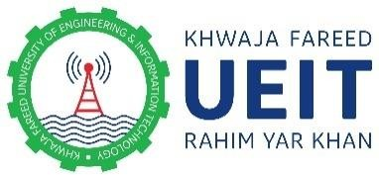
BE APART OF THE WINNING TEAM JOIN
KHWAJA FAREED UNIVERSITY
OF ENGINEERING AND INFORMATION TECHNOLOGY,
RAHIM YAR KHAN (KFUEIT, RYK)
WALK IN INTERVIEWS
Stipend / remuneration based situations are vacant for the following NRPU-HEC funded projects at the Khwaja Fareed University of Engineering and Information Technology, Rahim Yar Khan:

Sr | Project Title
1 | Mitigating the harmful consequences of despotic leadership in state owned utility based organizations
2 | Molecular designing and development of proficient organic semiconducting materials for electronic applications
3 | Synthesis and Evaluation of Non-Noble Metal Based Carbon supported Nanostructures towards Electrocatalytic Energy Conversion Applications
4 | Synthesis and characterization of Anion Exchange Membrane for fuel cell application
5 | Development and Assessment of Smartphone based Groundwater Irrigation Advisory Application (GIAA) for Sustainable Groundwater Management

Detail of posts and required qualification are as under:

Sr. | Detail | Qualification
1 | Research Associate | Fresh PhD from any HEC recognized university
2 | PhD Student | Must enrolled in PhD in any HEC recognized university
3 | MS / M. Phil Student | Must enrolled in MS/ M. Phil in any HEC recognized university
4 | Undergraduate Student | Must enrolled in undergraduate program (Final Year) in any HEC recognized university

TERM & CONDITIONS: -
1-The Candidates are required to appear in walk in interview along with CV and attested copies of testimonial/credentials at the Khwaja Fareed University of Engineering and Information Technology, Rahim Yar Khan on August 29, 2022 at 10:00 AM.
2-No TA/DA shall be admissible for interview.

For further information, please contact:
Office of the Registrar
Khwaja Fareed University of Engineering and Information Technology Abu Dhabi Road, Rahim Yar Khan
Phone: +92-68-5882432, +92-334-8707991

